Question 2.1

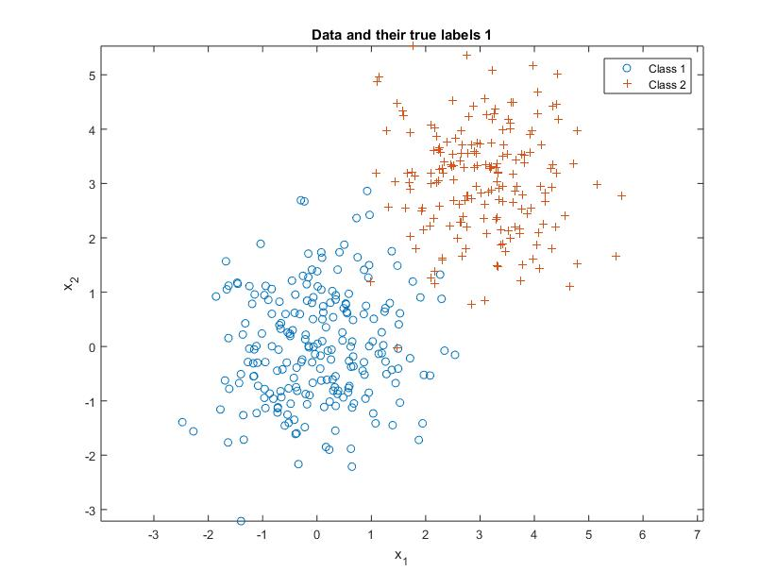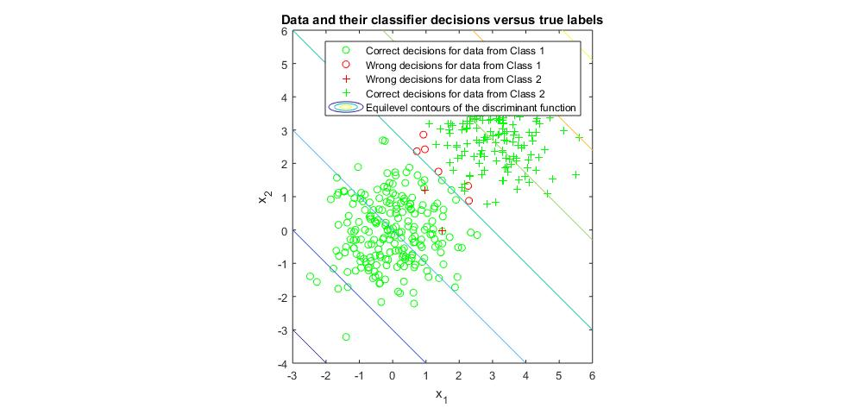

Question2.1 shows the two class with mean value (0,0)T, (3,3)T, sigma with I, Error = 0.02. Wrong decision for class 1 : 6 counts. Wring decision for class 2: 2 counts.

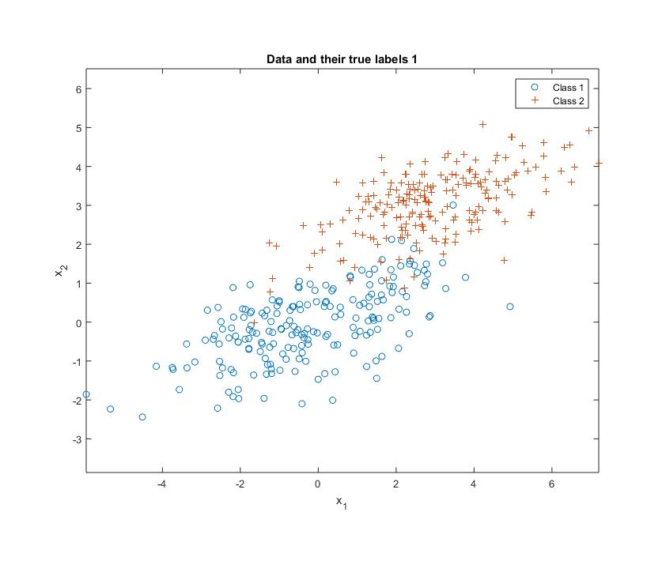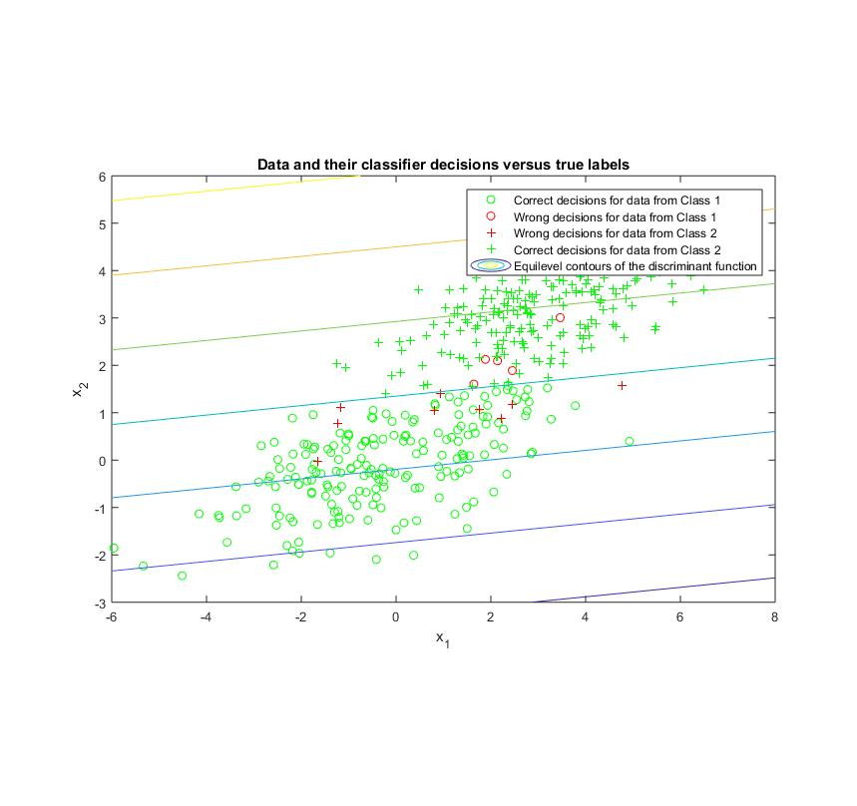

Question2.2 shows the two class with mean value same as 2.1 but sigma = [3,1; 1,0.8]. Error = 0.0275. Wrong decision for class 1: 5 counts. Wring decision for class 2: 9 counts.

Question 2.3

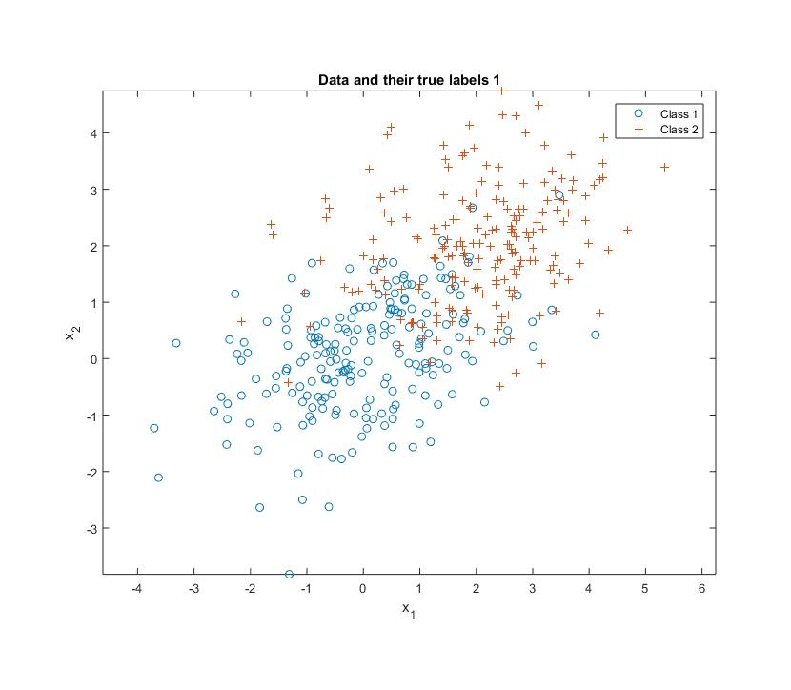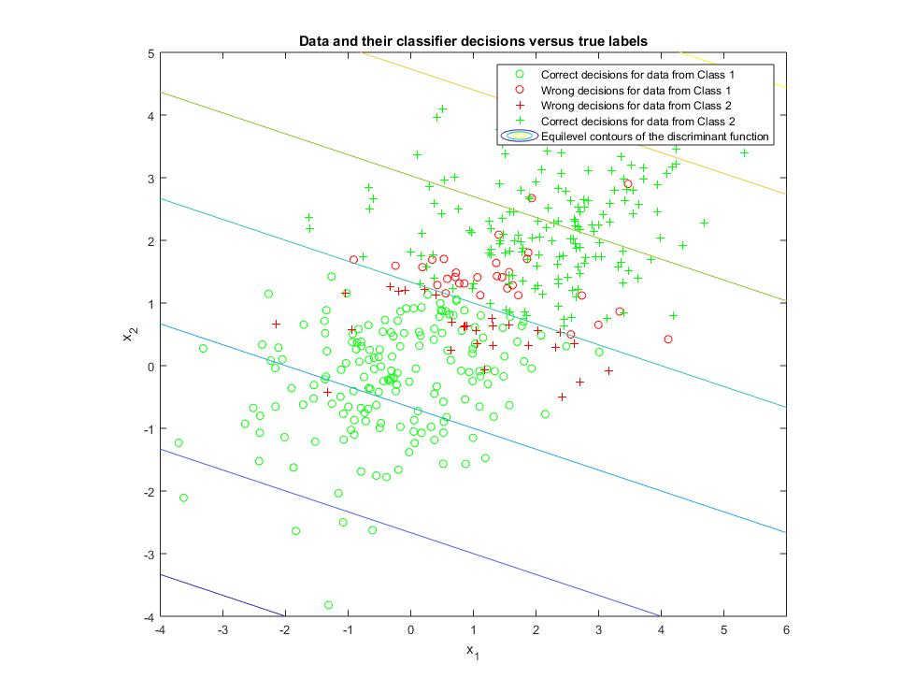

Question2.3 shows the two classes with mean value [0,0]T,[2,2]T, sigma = [2,0.5; 0.5,1]. Error = 0.15 Wrong decision for class 1: 31 counts. Wrong decision for class 2: 24 counts.

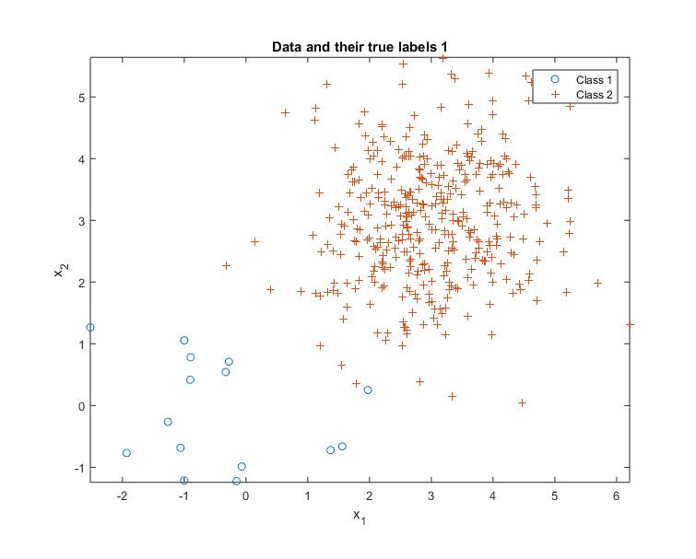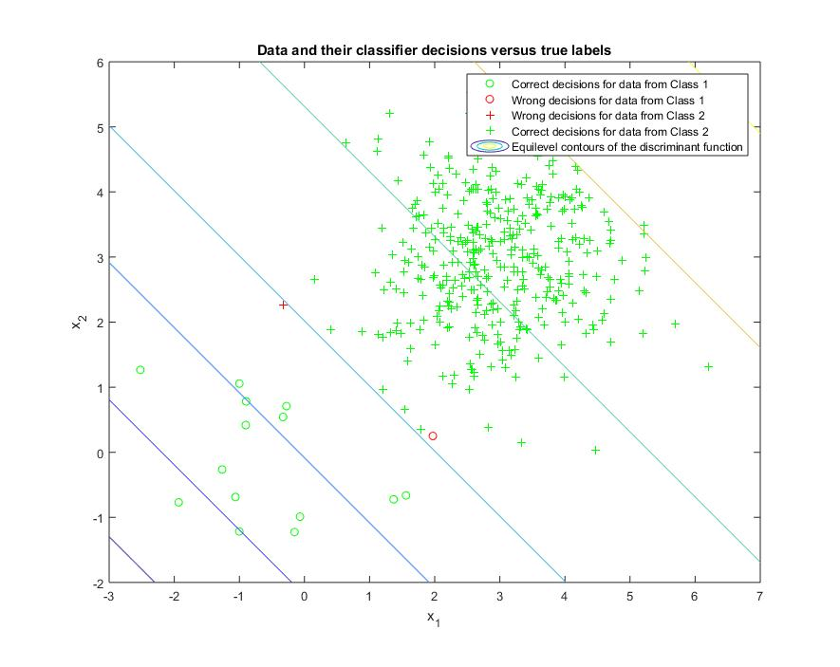

Question2.4 shows the two classes with same parameter as Q2.1 but with priors probability [0.05,0.95]. Error = 0.005. Wrong decision for class 1: 1 count. Wring decision for class 2: 1 count.

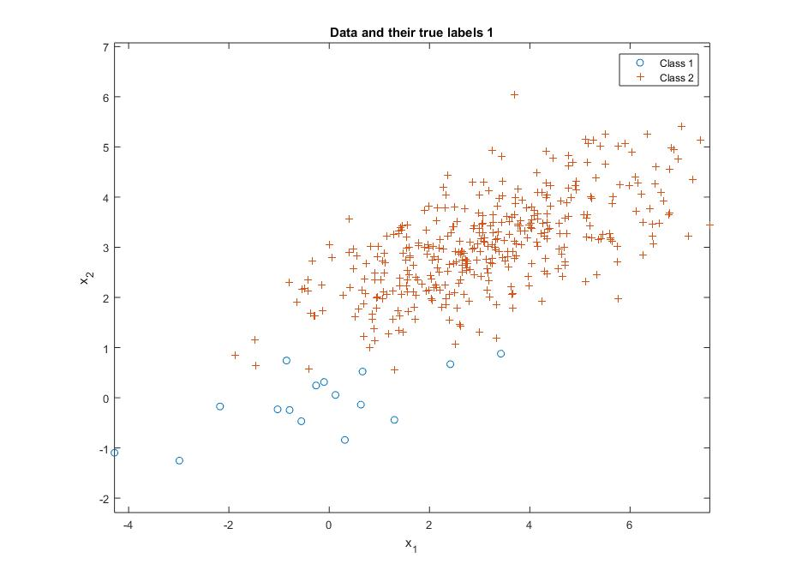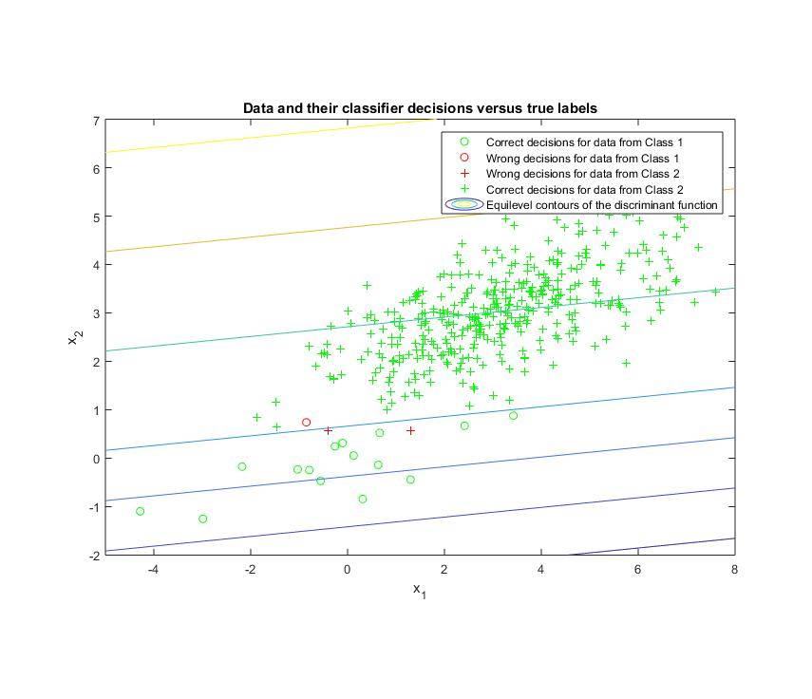

Question2.5 shows the two classes with same parameter as Q2.2 but with prior probability [0.05,0.95]. Error = 0.0075. Wring decision for class 1: 1 count. Wring decision for class 2: 2 counts.

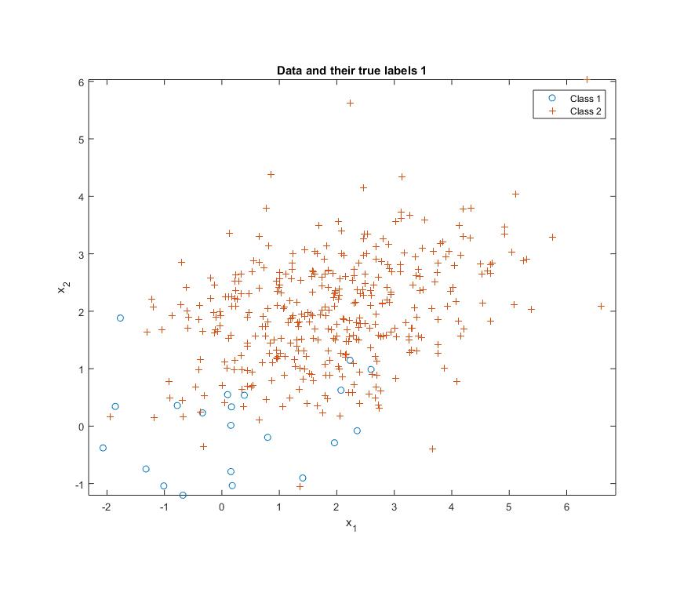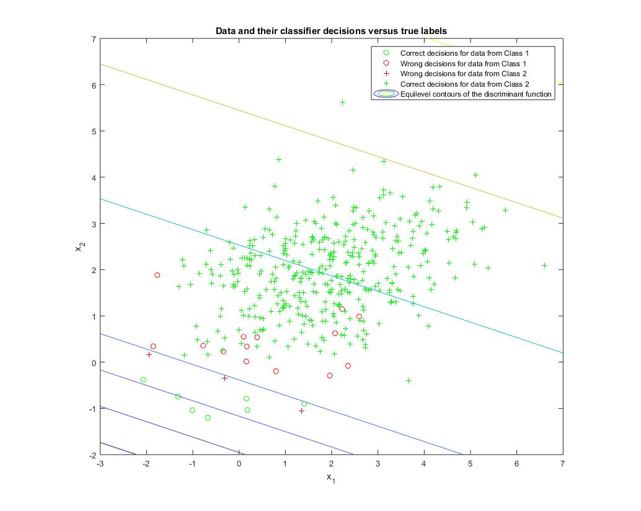

Question2.6 shows the two classes with the same parameter as Q2.3 but with prior probability [0.05,0.95]. Error = 0.0425. Wrong decision for class 1: 15 counts. Wrong decision for class 2: 3 counts.

Code : <https://github.com/MakiseYuki/EECE5644-Machine-Learning/blob/master/Homework%202/Question2and3.m>

Question3 LDA projections for Question2

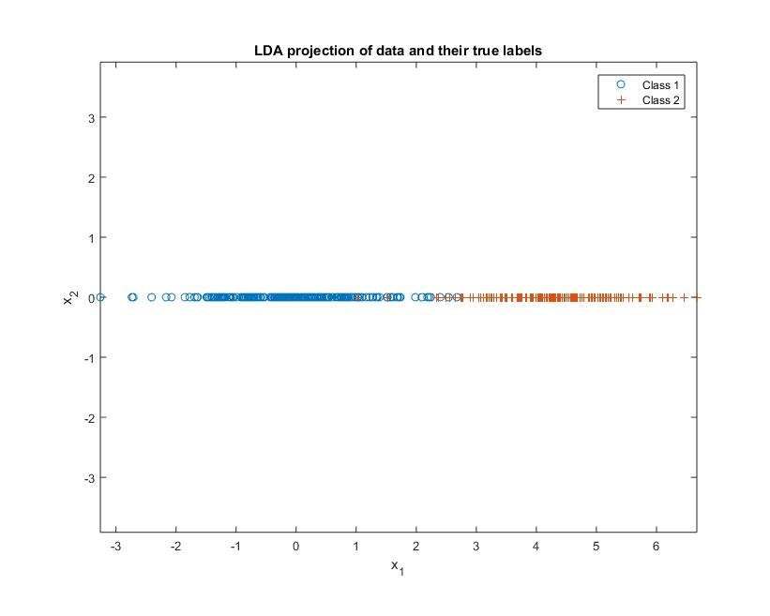Question2.1

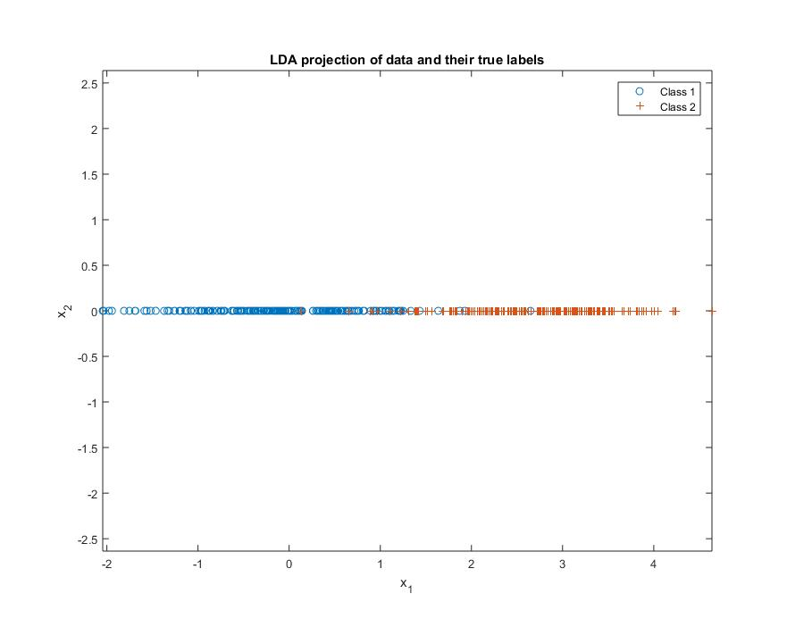Question2.2

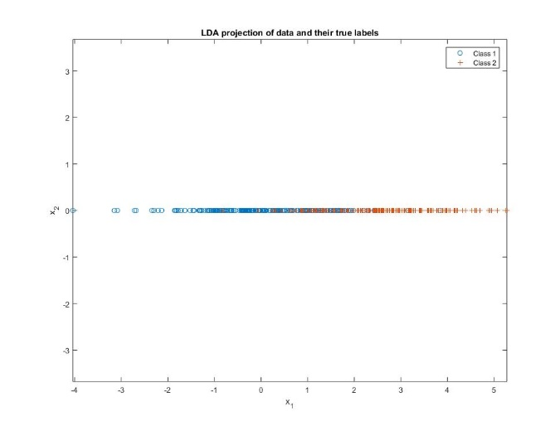Question2.3

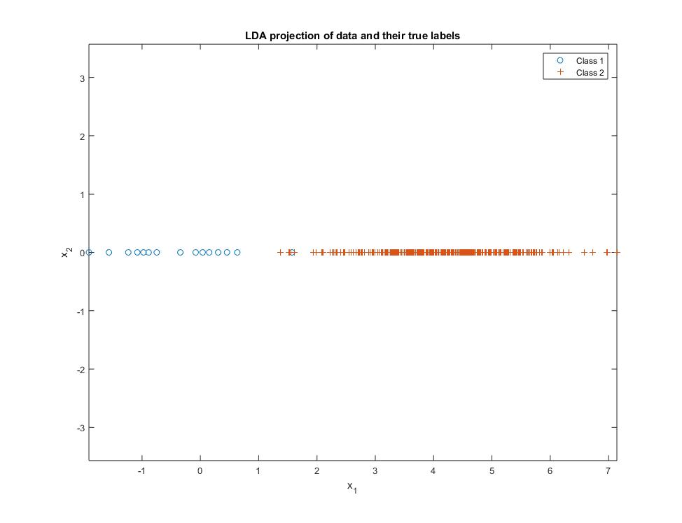Question2.4

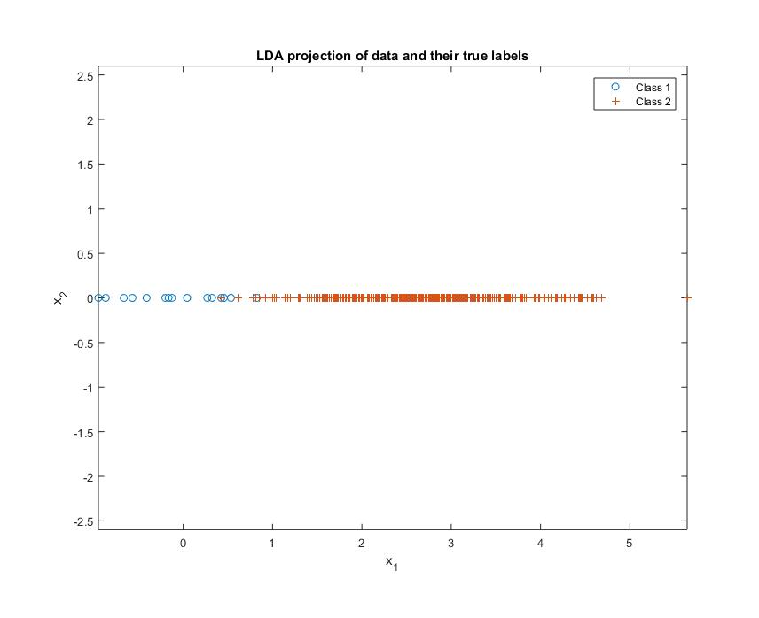Question2.5

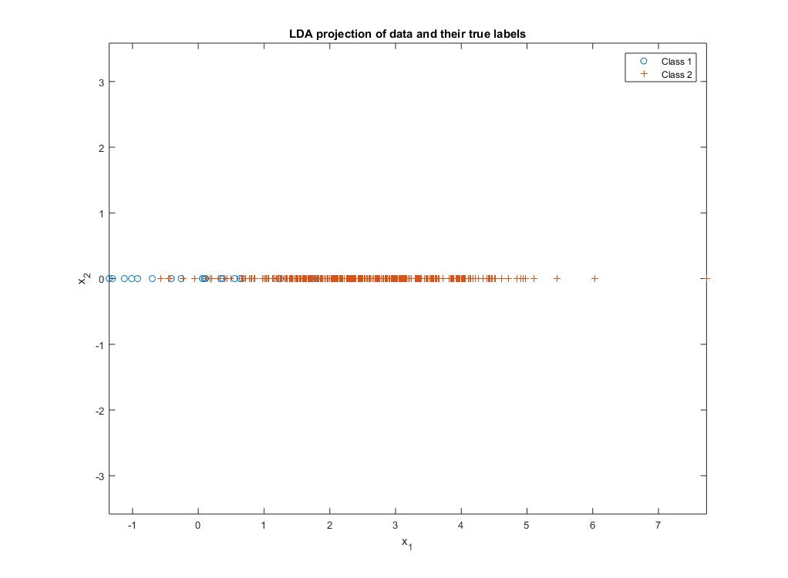Question2.6

Reference.

<https://pdfs.semanticscholar.org/1ab8/ea71fbef3b55b69e142897fadf43b3269463.pdf>

<https://www.mathworks.com/help/econ/customblm.html>

Textbook Chapter 2,